To send an instant message, type your message in the meeting window and press Enter. The instant messages that you send will be visible to all the meeting participants. You cannot send instant messages to individual participants. Use the Call Me option under Call if you want the conference to call you. This option is useful if you have to switch to attending the meeting from a different device such as a cellular phone. You can click a number from the drop-down list or specify a number for the conference to call you. To start sharing your video, click Video. You can also adjust the video settings if required. You don’t need a webcam to receive video.

Start sharing
If you’ve joined a meeting as a presenter, you can share. When you are in a meeting as an attendee, you don’t have the option to share. To start to use one of the sharing options, an organizer or presenter must make you a presenter.
- Click Share to see the available sharing activities.
- You can share your desktop on a specific monitor or on multiple monitors, share a specific program, share a PowerPoint presentation, use a whiteboard that attendees can take turns contributing to, and conduct a poll.
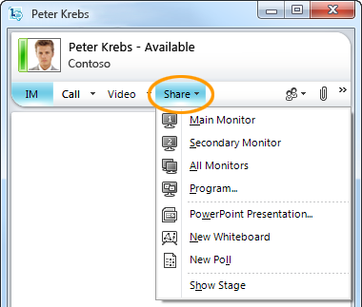

PRINT SETTINGS For best results, set printer options to: Paper Size: Letter (8.5x11”); Orientation: Landscape; 2-sided printing options: Two-sided, flip on short side.

© 2011 Microsoft. All Rights Reserved. This document is provided “as-is”. Information and views expressed in this document, including URL and other Internet Web site references, may change without notice. You bear the risk of using it. Some examples are for illustration only and are fictitious. No real association is intended or inferred.

Lync 2010 Attendee Quick Reference
If you don’t have Microsoft® Lync™ 2010 communications software installed, you can use Microsoft® Lync™ 2010 Attendee, a conferencing client that lets you participate in Lync 2010 online meetings.
Lync 2010 Attendee provides communication tools such as instant messaging (IM), audio, video, as well as collaboration tools such as program sharing, screen sharing, attachments, whiteboard, polling, and slide presentations.

Install Lync 2010 Attendee
The support team in your company may have already installed Attendee for you. If they have, you’ll see Microsoft Lync 2010 Attendee on the Start menu. Or, depending on how Lync was set up, you might be able to install Lync Attendee from the meeting link in the meeting invite, as follows:
- Click the Join online meeting link in an online meeting request.
- A screen with instructions for selecting a client to install is displayed. Click Download and install Lync Attendee.
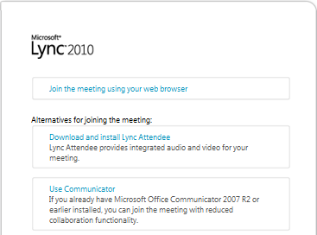
- A webpage with a download and install link will open. Follow the download and install instructions.
Join a Lync 2010 online meeting
You can use Attendee to join a Lync online meeting as a guest or an authenticated user.
- Click the Join online meeting link in an online meeting request.
- In the Microsoft Lync Attendee sign-in screen, select either Join as Guest, or Join using corporate credentials. If you have an account with the company that set up the meeting, you can join as an authenticated user.
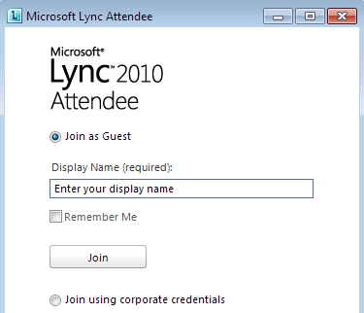
- To join as a guest, type a name to display at the meeting, and then click Join. To join as an authenticated user, type your company credentials, and then click Join.
Connecting to audio
If you have a microphone and speakers, you’re ready to use Attendee to talk and listen when in online meetings. You can also plug in any device recommended by your organization, such as a USB headset, USB phone or handset. Attendee automatically configures the settings, depending on the device that you connect. Or, you can call into the meeting using a phone line. The numbers that you could call will be in the meeting invitation.

Prepare Lync 2010 Attendee for a meeting
You can configure Attendee with all your choices for different settings so that you don’t need to re-enter them before each meeting.
- Click Start, click All Programs, and then click Microsoft Lync 2010 Attendee. The Lync Attendee - Options dialog box appears.
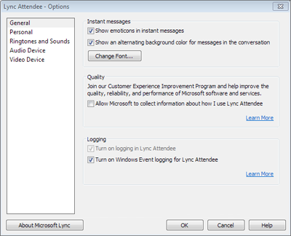
Review the General, Personal, Ringtones and Sounds, Audio Device, and Video Device options to make sure that they apply to what you want to do, or change them if required.
Start IM, audio or video
As soon as you’re admitted to a meeting by a presenter or an organizer, you’ll see the meeting window. You can then participate using IM, audio and video.
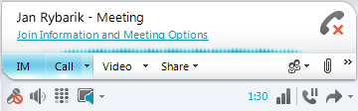
- Click IM, Call, or Video, depending on what you want to do.

